Mini Piano using Buzzer
Description:
This project creates a small electronic piano using an Arduino, push buttons, and a piezo buzzer. Each button represents a musical note such as C, D, E, F, or G. When pressed, the buzzer produces the corresponding frequency.
Block Diagram:
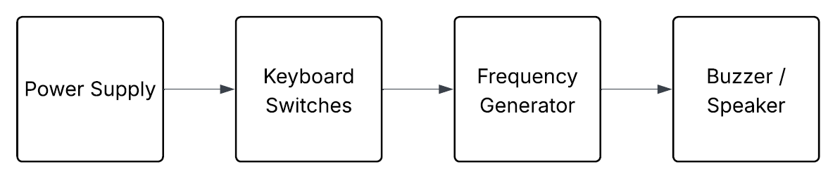
Pinout / Circuit Connection:
- Push buttons → Digital Pins 2–5
- Buzzer → Digital Pin 9
- Resistors for buttons (10kΩ pull-down)

Components Required:
- Arduino UNO
- Buzzer
- Push buttons (5)
- 10kΩ resistors
- Breadboard & jumper wires
Working Principle:
Each button is connected to a digital input pin. When pressed, the Arduino detects HIGH input and sends a PWM signal at a specific frequency to the buzzer. Each frequency corresponds to a musical note, e.g., 262 Hz for C, 294 Hz for D, etc. By pressing different buttons, different tones are generated, simulating a mini piano. The tone() function allows precise generation of square waves that drive the buzzer.
Operation (Step-by-Step):
- Connect buttons to Arduino inputs.
- Connect buzzer to D9.
- Upload code.
- Press different buttons → buzzer produces musical notes.
Code:
int buzzer = 9;

int switch1 = 2;
int switch2 = 3;
int switch3 = 4;
int switch4 = 5;

void setup() {
pinMode(buzzer, OUTPUT);

pinMode(switch1, INPUT_PULLUP);
pinMode(switch2, INPUT_PULLUP);
pinMode(switch3, INPUT_PULLUP);
pinMode(switch4, INPUT_PULLUP);
}

void loop() {
if (digitalRead(switch1) == LOW) {
tone(buzzer, 262); // C note
}
else if (digitalRead(switch2) == LOW) {
tone(buzzer, 294); // D note
}
else if (digitalRead(switch3) == LOW) {
tone(buzzer, 330); // E note
}
else if (digitalRead(switch4) == LOW) {
tone(buzzer, 349); // F note
}
else {
noTone(buzzer); // Stop sound
}
}
Conclusion:
The mini piano project combines electronics and music in a simple yet educational way. It provides an engaging introduction to both hardware and coding, and can be extended to include more notes, polyphonic output, or even recording of tunes.

References:
[1] Arduino.cc, “Tone() – Arduino Reference,” 2023. [Online]. Available: https://www.arduino.cc/reference/en/language/functions/advanced-io/tone/. [Accessed: Sep. 13, 2025].
[2] M. Banzi and M. Shiloh, “Getting Started with Arduino,” 3rd ed., Maker Media, 2014.
. make file

